Information Design Tool

How to create a universe
Make sure you have the appropriate rights defined in the Central Management Console (CMC).
Connections for multisource-enabled data foundations must be secured, relational connections, and are managed by the data federation service.
If you want to base your universe on secured connections, the connection shortcuts must exist in a local project.
You can use the New Universe wizard to create the resources you need to publish a local universe - either a single-source relational or OLAP universe. For OLAP universes, you do not need to create a data foundation. The business layer is built directly from the objects you select in the source cube.

Working with connections

The connection can be –
- a local file,
- a remote object in a repository that is referenced by a local shortcut in the IDT (information design tool).
To create a multisource-enabled data foundation, you must reference secured connections.
To secure a local connection, you publish the connection to a repository.

Виды источников данных
Relational data source for a data foundation - when you publish the business layer as a universe, the connections and data foundation are integrated in the universe and provide the data for queries run against the universe.
OLAP data source for a business layer - the business layer is published as a universe, but the connection provides direct access to the cube.

Direct access
Direct access to an SAP BW BEx Query - you define SAP BW connections that use the SAP BICS Client middleware driver to provide access to a BEx Query. You cannot use these connections as a source for business layers or universes.
Direct access to an SAP HANA information model - you define SAP HANA connections that use the SAP HANA Client middleware driver to provide direct access to a single information model (such as an Analytic View or Calculation View). You cannot use these connections as a source for business layers or universes.

Creating a relational connection

You must create relational connections to SAP BW and SAS sources directly in the repository as secured connections.
SAP BW and SAS connections are only listed if you are creating the connection directly in the repository.
If you are using the IDT from a Crystal Server 2011 installation, SAP middleware drivers are not available.

Creating an OLAP connection

Before you create a local connection in the IDT, you must have a project available in the Local Projects View.
The OLAP connections you create in the IDT are not supported by the universe design tool. Also, OLAP connections created in the universe design tool are not available for building universes in the IDT.
Local connections are saved as independent objects on the local file system as .cnx files.

To create a local connection -
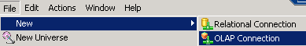
или
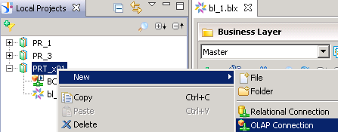

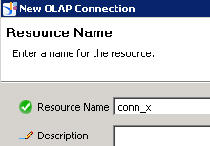

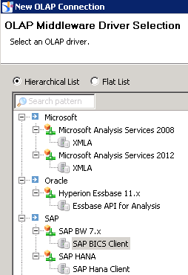

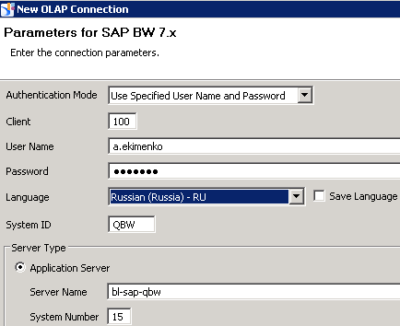
Пароль shm7072

To create a secured connection, in the Repository Resources View, open a session on the repository where you want to create the secured connection -

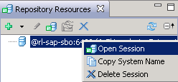

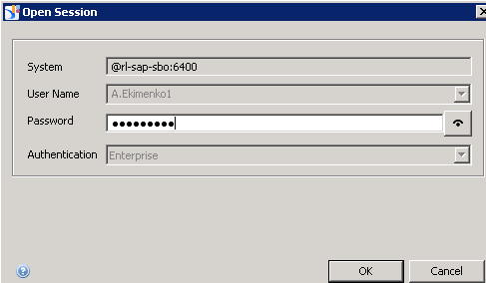
Пароль - Qa1234567.

Right-click the Connections folder or subfolder in the repository, and select Insert Relational Connection –

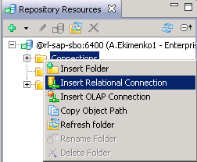.

Creating a connection shortcut

A connection shortcut is an object that references a secured connection in a repository. The shortcut is saved as a .cns file on the local file system.
When you publish a connection, you have the option of creating a connection shortcut in the Local Projects View for an existing secured connection.
Rem. - you must have a local project in the Local Projects View.

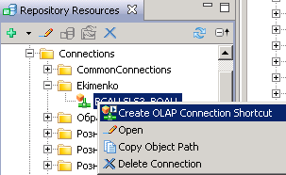

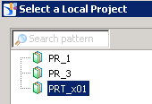

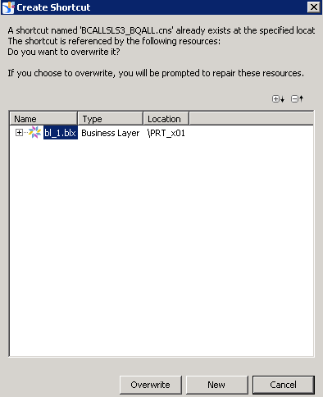

Creating Universes

- How to create a universe with the IDT
Connections for multisource-enabled data foundations must be secured, relational connections, and are managed by the data federation service.
For OLAP universes, you do not need to create a data foundation. The business layer is built directly from the objects you select in the source cube.
You can use the New Universe wizard to create the resources you need to publish a local universe - either a single-source relational or OLAP universe. If you want to base your universe on secured connections, the connection shortcuts must exist in a local project. The wizard lets you create only local connections. To start the wizard, select 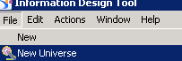.
1. Create a local project.
2. Define the connections -
- Use a local connection if you want to publish the universe on the local file system (later, you can publish the business layer to a repository) –
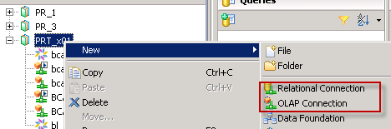
- Create a secured connection if you want to create a multisource-enabled universe, or if you want to publish the universe in a repository without first publishing locally. For secured connections, you must create connection shortcuts in the local project to reference the secured connections in the repository.
To create a secured connection –
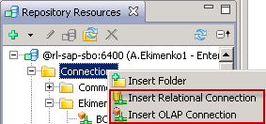
To create a connection shortcut –
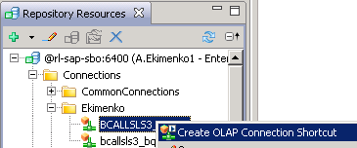
- Create the data foundation (relational data sources only) - 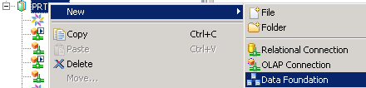.
For a single-source universe, select a single connection identifying the database source.
To build a data foundation with multiple relational connections, create a multisource-enabled data foundation.
- Create the business layer - 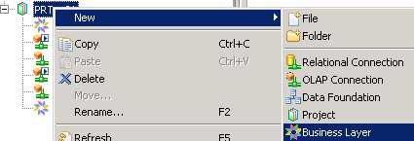.
For relational business layers, select the data foundation to be the basis for the business layer. You can choose to automatically generate objects in the business layer for all data foundation structures, or select columns to be mapped as objects.
Note To build a universe on multiple data sources (relational data sources only), the business layer must be based on a multisource-enabled data foundation.
For OLAP business layers, select the connection to the OLAP cube. Objects are created automatically for all structures in the cube.

- Publish the business layer (locally or to repository) –
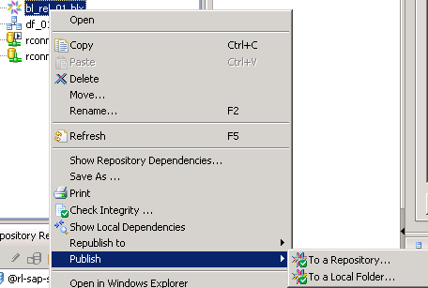
- Define universe security –
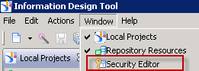

Working with business layers

About business layers

Business layers can be created directly on an OLAP cube, or on a data foundation that is built on a relational database.
When a business layer is complete, it is published to a repository or a local folder as a universe. A universe is a published .unx file that includes a business layer and its connection to an OLAP cube, or a business layer and its corresponding data foundation.

About business layer objects

Objects can have three states –
- Active - object is visible in the Query Panel.
- Hidden - object is valid but not available in the Query Panel.
- Deprecated - object is hidden and not valid (you want to keep the object for possible future use).

Attributes can be defined for dimensions, measures, hierarchies, and levels.
In an OLAP business layer, a measure attribute provides information for the formatted value.

Analysis dimension (OLAP only) allows you to logically group dimensions and hierarchies that share the same axis of analysis. Analysis dimensions are often used for hierarchical analysis.
You define a default hierarchy ('haɪərɑːkɪ) for the analysis dimension. This is the hierarchy used when the entire analysis dimension is included as a result object in a query.

Hierarchy (OLAP only) is the representation in the business layer of the hierarchy in the OLAP cube. If the hierarchy in the cube is level-based, level objects in the business layer represent the levels.
If the hierarchy in the cube is value-based (parent-child), the levels are not represented in the business layer. Value-based hierarchies generated automatically in the business layer have the following icon .
Named set (OLAP only) is a collection of members of a hierarchy in the business layer. A business named set is defined by selecting members.
Calculated member (OLAP only) is a member of a hierarchy that is calculated using an explicitly defined MDX expression that can include data from the OLAP cube, mathematical operators, numbers, and functions.
Calculated members are available in the Member Selector when creating queries.

Обновление business layer
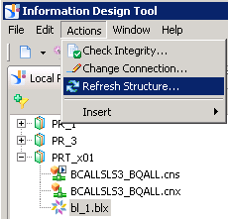
.cnx – local connection
.cns – connection shortcut

Проблема
Web Intelligence Applet cannot be loaded, please make sure you have installed a Java virtual machine
Лечение
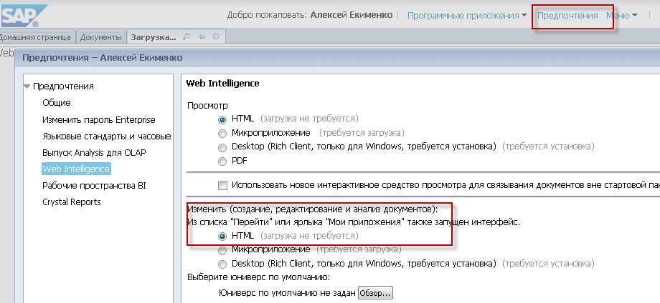

Relation Connection
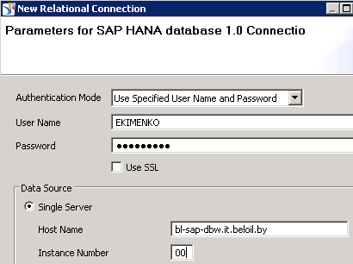

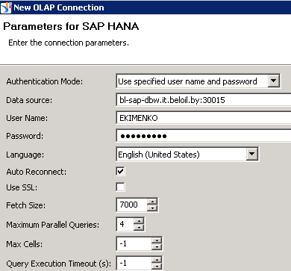
bl-sap-dbw.it.beloil.by:30015

QAS
URL http://sapbo-qas.it.beloil.by/BOE/BI
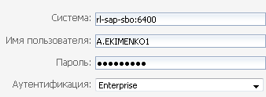
Логин a.ekimenko1
Пароль Qa1234567

